**Database Assignment 1**

**Name :- Rupali Barnwal**

**Roll:-1705163**

1. Write a SQL statement to display all the information of all salesmen for the following table salesman.

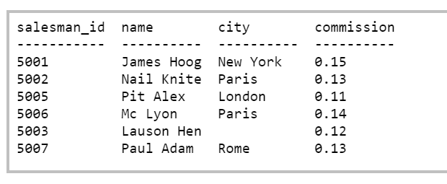

Ans:-SELECT * FROM salesman;

1. Write a SQL statement to display a string "This is SQL Exercise, Practice and Solution".

Ans:-SELECT "This is SQL Exercise, Practice and Solution";

1. Write a query to display the result of an arithmetic expression.

For example the result of expression 9*10+4

Ans:-SELECT 9*10+4 ;

1. Write a query to display ord_date, salesman_id, customer_id, order no, and purchase amount in the sequence from following orders table.

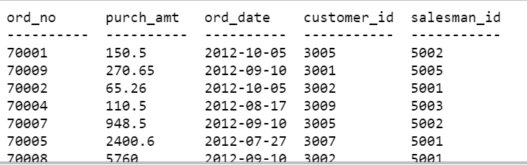

Ans:-SELECT ord_date, salesman_id, ord_no, purch_amt FROM orders;

1. For the above table display salesman_id for all the salesman without repetitive value of the salesman_id.

Ans:-SELECT DISTINCT salesman_id FROM orders;

1. Write a SQL statement to display all the information for those customers with a grade of 200.

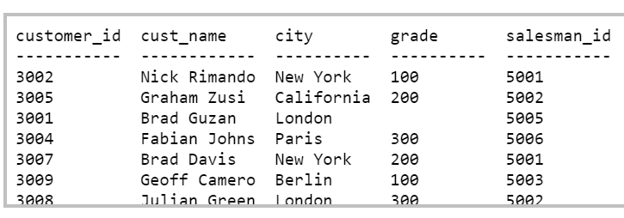

Ans:-SELECT *FROM customer WHERE grade=200;

1. List the number, name, credit limit, and balance for customers with credit limits that exceed their balances.

(Where table attributes are number,name,credit limit and balance).

Ans:- SELECT number,name, credit_limit ,balance FROM Customer WHERE credit_limit>balance

1. Create a table which consists of attributes warehouse id,warehouse branch address,customers numbers and balance for each warehouse. Then List the description of all parts that are not in warehouse 3.

Ans:- CREATE TABLE warehouse(id INT PRIMARY KEY NOT NULL, branch_address VARCHAR(40),customer_number INT, balance FLOAT(30));

SELECT* FROM warehouse WHERE id <3 and id>3;

1. Explain the following terms briefly: attribute, domain, entity, relationship, entity set, relationship set, one-to-many relationship, many-to-many relationship, overlap constraint, and weak entity set.

Ans:- **Attribute** - a property or description of an entity. A toy department employee entity could have attributes describing the employee’s name, salary, and years of service.  
  
**Domain** - a set of possible values for an attribute.  
  
**Entity** - an object in the real world that is distinguishable from other objects such as the green dragon toy. Relationship - an association among two or more entities.  
  
**Entity set** - a collection of similar entities such as all of the toys in the toy department.  
  
**Relationship set** - a collection of similar relationships

**One-to-many relationship** - a key constraint that indicates that one entity can be associated with many of another entity.

**Many-to-many relationship** - a key constraint that indicates that many of one entity can be associated with many of another entity.

**Overlap constraint**- within an ISA hierarchy, an overlap constraint determines whether or not two subclasses can contain the same entity.

**Weak entity set**- an entity that cannot be identified uniquely without considering some primary key attributes of another identifying owner entity.

1. What is a foreign key constraint?

Ans:-

A foreign key is a column (or combination of columns) in a

table whose values must match values of a column in some other table. FOREIGN KEY constraints enforce [referential integrity](https://en.wikipedia.org/wiki/Referential_integrity), which essentially says that if column value A refers to column value B, then column value B must exist.

1. Answer each of the following questions briefly. The questions are based on the following relational schema:

Emp(eid: integer, ename: string, age: integer, salary: real)

Works(eid: integer, did: integer, pcttime: integer)

Dept(did: integer, dname: string, budget: real, managerid: integer)

1. . Give an example of a foreign key constraint that involves the Dept relation. What are the options for enforcing this constraint when a user attempts to delete a Dept tuple?

Ans:- CREATE TABLE Works ( eid INTEGER NOT NULL , did INTEGER NOT NULL , pcttime INTEGER, PRIMARY KEY (eid, did), UNIQUE (eid), FOREIGN KEY (did) REFERENCES Dept )

1. Write the SQL statements required to create the preceding relations, including appropriate versions of all primary and foreign key integrity constraints.

Ans:-

CREATE TABLE Emp ( eid INTEGER, ename CHAR(10), age INTEGER, salary REAL, PRIMARY KEY (eid) )

CREATE TABLE Works ( eid INTEGER, did INTEGER, pcttime INTEGER, PRIMARY KEY (eid, did), FOREIGN KEY (did) REFERENCES Dept, FOREIGN KEY (eid) REFERENCES Emp, ON DELETE CASCADE)

CREATE TABLE Dept ( did INTEGER, budget REAL, managerid INTEGER , PRIMARY KEY (did), FOREIGN KEY (managerid) REFERENCES Emp, ON DELETE SET NULL)

1. Define the Dept relation in SQL so that every department is guaranteed to have a manager.

Ans:-

CREATE TABLE Dept ( did INTEGER, budget REAL, managerid INTEGER NOT NULL , PRIMARY KEY (did), FOREIGN KEY (managerid) REFERENCES Emp)

1. Write an SQL statement to add John Doe as an employee with eid = 101, age = 32 and salary = 15, 000.

Ans:- INSERT INTO Emp (eid, ename, age, salary) VALUES (101, ’John Doe’, 32, 15000)

1. Write an SQL statement to give every employee a 10 percent raise.

Ans:- UPDATE Emp E SET E.salary = E.salary * 1.10

1. Write an SQL statement to delete the Toy department.

Ans:- DELETE FROM Dept D WHERE D.dname = ’Toy’